Carleton University
Department of Systems and Computer Engineering

SYSC 5104 : Methodologies for Discrete –Event Modeling and Simulation
Fall Semester 2011

Assignment #2

Saman Jafartayari
uOttawa# 5453154

Contents
Introduction: 3
Neighborhoods: 3
Transition rules 4
Free moving rule: 4
Background: 4
Definitions: 4
Receiving moving cells: 4
Clearing the previous position: 5
Generating the directions randomly: 5
Transition rules: 5
Breaking rule: 5
Joining rules: 6
Testing strategies: 7
The initial values of the cells: 7
Free movement of ingredients: 7
Testing the Transition rules: 10
Testing the breaking rules: 12
Testing the joining rules: 13
DEVS Formalism 14
References 14

Introduction:

This is an attempt to simulate a simple chemical system containing two ingredients.
Some characteristics are defined such as breaking rules, joining rules, free movement, reactions and transitions. Each of these specifications is defined through a probability (ex. free moving probability). All these values can be modified based on different systems.

In this model, we consider the chemical system as a two dimensional 30*30 atomic model. The initial values are generated randomly using Microsoft Excel.

Neighborhoods:
The neighborhood defined in this simulation (Figure 1) is the extended von Neumann neighborhood (figure 2a) combined with the Moore neighborhood (figure 2b).
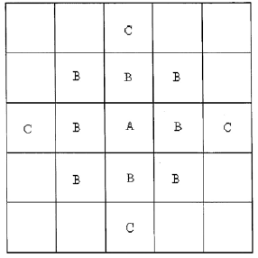
Figure 1 Combined Neighborhood

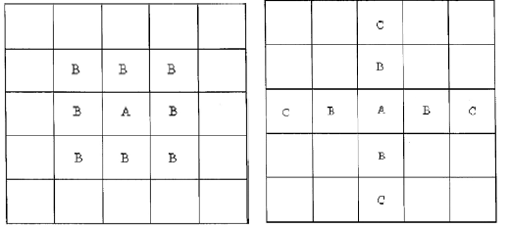
Figure 2: a)Von Neumann neighborhood. b) Moore Neighborhood

Transition rules

Each of the characteristics requires its own set of rules. These rules are described in the following:

Free moving rule:

Background:

Depending on the viscosity and many other characteristics of a chemical system, ingredients can sometimes move freely with a specific speed around their surrounding materials. The speed of this movement can vary in different chemical systems. This speed is defined through a value called free moving probability. The higher the probability is the higher the speed. A probability of 1 shows that in each of the frames (time sections) if there is any empty space around the cell and the other joining and breaking forces do not interfere, the cell moves randomly to fill the space around it. The probability of 0, defines a cell which does not move freely around its environment[1].

Definitions:
In free movements, there are four possible directions for each of the cells; East, West, North, South.
A stagnant cell is defined to have the value of 1 or 2(for ingredient 1 and 2). According to the direction a cell is heading, a type 1 moving cell can get the value of 5,6, 7, 8(for East, West, North and South respectively) and a type 2 moving cell can be allocated by the values of 9,10,11,12(for East, West, North and South respectively).

This rule consists of three parts of generating directions, receiving moving cells in their new position and clearing the previous position of the cells:

These subparts are described in details based on the sequence in which they are applied in the model:

Receiving moving cells:
rule : { 2 } 50 { (0,0) = 0 and
((0,1) = 10 or (0,-1) = 9 or (-1,0) = 11 or (1,0) = 12) }

rule : { 1 } 50 { (0,0) = 0 and
((0,1) = 6 or (0,-1) = 5 or (-1,0) = 7 or (1,0) = 8) }

The above code is used for the destination cells; As shown, an empty type 2-cell changes in value from 0 to 2 whenever a neighboring cell has value showing the intention to occupy an empty cell, meaning that for example the cell at the right wants to move towards West ((0,1) = 10) or a cell at left is heading Eastward(0,-1) = 9 and etc.
This applies to a type 1 cell, as seen in the second rule above.

Clearing the previous position:
The cell which has found an empty neighbor moves towards it and therefore it needs to get the value of 0:

rule : { if((0,1) = 0, 0, 2) } 50 { (0,0) = 9 }
rule : { if((0,-1) = 0, 0, 2) } 50 { (0,0) = 10 }
rule : { if((1,0) = 0, 0, 2) } 50 { (0,0) = 11 }
rule : { if((-1,0) = 0, 0, 2) } 50 { (0,0) = 12 }

rule : { if((0,1) = 0, 0, 1) } 50 { (0,0) = 5 }
rule : { if((0,-1) = 0, 0, 1) } 50 { (0,0) = 6 }
rule : { if((1,0) = 0, 0, 1) } 50 { (0,0) = 7 }
rule : { if((-1,0) = 0, 0, 1) } 50 { (0,0) = 8 }

Generating the directions randomly:

rule : {5} 50 {(0,0) = 1 and (0,1) = 0 and #Macro(FM1)}
rule : {6} 50 {(0,0) = 1 and (0,-1) = 0 and #Macro(FM2) }
rule : {7} 50 {(0,0) = 1 and (1,0) = 0 and #Macro(FM3)}
rule : {8} 50 {(0,0) = 1 and (-1,0) = 0 and #Macro(FM4)}

rule : {9} 50 {(0,0)=2 and (0,1) = 0 and #Macro(FM1)}
rule : {10} 50 {(0,0)=2 and (0,-1) = 0 and #Macro(FM2)}
rule : {11} 50 {(0,0)=2 and (1,0) = 0 and #Macro(FM3)}
rule : {12} 50 {(0,0)=2 and (-1,0) = 0 and #Macro(FM4)

The above rules are used to generate numbers which represent the direction of the cells based on their type.

A Macro set is used to control the probability of free movements. The initial values are set to be 0.25 each. This implies that if we need to has a slower speed we can simply multiply the free moving probability by this current value. For example if the probability is 0.5, the values of FM1 to FM4 are to be set as 0.125.

Transition rules:

In some systems ingredients transform from one type to another. In the current chemical system we have two possibilities of transitions: one is from type 1 to type 2 ingredients and the second is from type 2 to type1 [1].

These possibilities are defined in the pertinent Macro(TPxy and TPyx). For instance, setting value of TPxy to 0.5 means that the transition from type 1 to type 2 ingredients can occur by the probability of 50 percent. The corresponding code is as followed:

%Transition rule(ex. molecules change from one tautomeric form to another)
rule : { 2 } 50 {#Macro(TPxy) and (0,0) = 1}
rule : { 1 } 50 {#Macro(TPyx) and (0,0) = 2}

Breaking rule:

Breaking rules show the inclination that two cells have towards being away from each other.

rule : { if( (0,1) = 2, 6 ,if( (0,-1) = 2, 5 ,if( (1,0) = 2, 8 ,7))) } 50 {#Macro(BPxy) and (0,0) = 1 and #Macro(CountState21) }
%rule : { if( ((0,1) = 0 and (0,-1) = 0), 8 , if( ((1,0) = 0 and (-1,0) = 0), (1+((randInt(1)+3)*0.1)) , if( ((0,1) = 0 and (1,0) = 0), 7 , if( ((0,1) = 0 and (-1,0) = 0), 8 , if( ((0,-1) = 0 and (1,0) = 0), (1+((randInt(1)+2)*0.1)) , 8 ))))) } 50 {#Macro(BP2xy) and (0,0) = 1 and stateCount(2) = 2 }
rule : { if( (0,1) = 1, 10 ,if( (0,-1) = 1, 9 ,if( (1,0) = 1, 12 ,11))) } 50 {#Macro(BPyx) and (0,0) = 2 and #Macro(CountState11) }
%rule : { if( ((0,1) = 0 and (0,-1) = 0), 12 , if( ((1,0) = 0 and (-1,0) = 0), (2+((randInt(1)+3)*0.1)) , if( ((0,1) = 0 and (1,0) = 0), 11 , if( ((0,1) = 0 and (-1,0) = 0), 12 , if( ((0,-1) = 0 and (1,0) = 0), (2+((randInt(1)+2)*0.1)) , 12 ))))) } 50 {#Macro(BP2yx) and (0,0) = 2 and #Macro(CountState12) }

rule : { if( (0,1) = 1, 6 ,if( (0,-1) = 1, 5 ,if( (1,0) = 1, 8 ,7))) } 50 {#Macro(BPxx) and #Macro(CountState11) and (0,0) = 1 and #Macro(CountState20) }
%rule : { if( ((0,1) = 0 and (0,-1) = 0), 8 , if( ((1,0) = 0 and (-1,0) = 0), (1+((randInt(1)+3)*0.1)) , if( ((0,1) = 0 and (1,0) = 0), 7 , if( ((0,1) = 0 and (-1,0) = 0), 8 , if( ((0,-1) = 0 and (1,0) = 0), (1+((randInt(1)+2)*0.1)) , 8 ))))) } 50 {#Macro(BP2xx) and #Macro(CountState20) and stateCount(1) = 3 and (0,0) = 1 }

rule : { if( (0,1) = 2, 10 ,if( (0,-1) = 2, 9 ,if( (1,0) = 2, 12 ,11))) } 50 {#Macro(BPyy) and #Macro(CountState10) and #Macro(CountState21) and (0,0) = 2 }
%rule : { if( ((0,1) = 0 and (0,-1) = 0), 12 , if( ((1,0) = 0 and (-1,0) = 0), (2+((randInt(1)+3)*0.1)) , if( ((0,1) = 0 and (1,0) = 0), 11 , if( ((0,1) = 0 and (-1,0) = 0), 12 , if( ((0,-1) = 0 and (1,0) = 0), (2+((randInt(1)+2)*0.1)) , 12 ))))) } 50 {#Macro(BP2yy) and #Macro(CountState10) and stateCount(2) = 3 and (0,0) = 2 }

Joining rules:
Joining rule carry the probability that if there is an empty space between two cells the cells stick to each other. For example joining probability of xy shows the tendency that the x cells has toward the y type ingredient. This means that if there is an empty space between a type 1 and type 2 cell, cell type 1 sticks to cell type 2 with a certain probability.

The code corresponding to Joining rules are as followed:
rule : {5} 50 {#Macro(Jxy) and (0,2) = 2 and (0,0) = 1 and (0,1) = 0 }
rule : {6} 50 {#Macro(Jxy) and (0,-2) = 2 and (0,0) = 1 and (0,-1) = 0 }
rule : {7} 50 {#Macro(Jxy) and (2,0) = 2 and (0,0) = 1 and (1,0) = 0 }
rule : {8} 50 {#Macro(Jxy) and (-2,0) = 2 and (0,0) = 1 and (-1,0) = 0 }

rule : {9} 50 {#Macro(Jyx) and (0,2) = 1 and (0,0) = 2 and (0,1) = 0 }
rule : {10} 50 {#Macro(Jyx) and (0,-2) = 1 and (0,0) = 2 and (0,-1) = 0 }
rule : {11} 50 {#Macro(Jyx) and (2,0) = 1 and (0,0) = 2 and (1,0) = 0 }
rule : {12} 50 {#Macro(Jyx) and (-2,0) = 1 and (0,0) = 2 and (-1,0) = 0 }

rule : {9} 50 {#Macro(Jyy) and (0,2) = 2 and (0,0) = 2 and (0,1) = 0 }
rule : {10} 50 {#Macro(Jyy) and (0,-2) = 2 and (0,0) = 2 and (0,-1) = 0 }
rule : {11} 50 {#Macro(Jyy) and (2,0) = 2 and (0,0) = 2 and (1,0) = 0 }
rule : {12} 50 {#Macro(Jyy) and (-2,0) = 2 and (0,0) = 2 and (-1,0) = 0 }

rule : {5} 50 {#Macro(Jxx) and (0,2) = 1 and (0,0) = 1 and (0,1) = 0 }
rule : {6} 50 {#Macro(Jxx) and (0,-2) = 1 and (0,0) = 1 and (0,-1) = 0 }
rule : {7} 50 {#Macro(Jxx) and (2,0) = 1 and (0,0) = 1 and (1,0) = 0 }
rule : {8} 50 {#Macro(Jxx) and (-2,0) = 1 and (0,0) = 1 and (-1,0) = 0 }

Testing strategies:

The initial values of the cells:

Initially there are 50 cells of mixed ingredients of type 1 and 2 scattered all over the grid. These values are randomly generated using Microsoft Excel.

Free movement of ingredients:
To test the free movement of cells we need to discard all the other factors by setting their probabilities to 0 and fully activate the free movement characteristic by setting it to 1.
The first 5 slides are shown in the following figures:

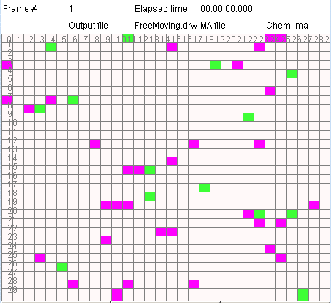
Figure 3: Frame 1-Free moving
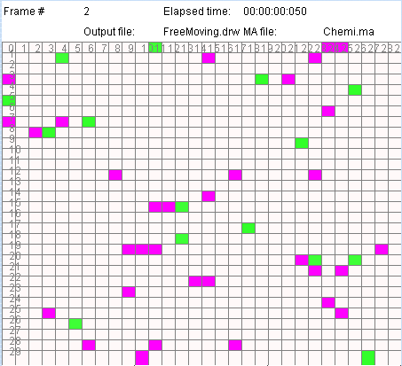
Figure 4: Frame 2-Free moving
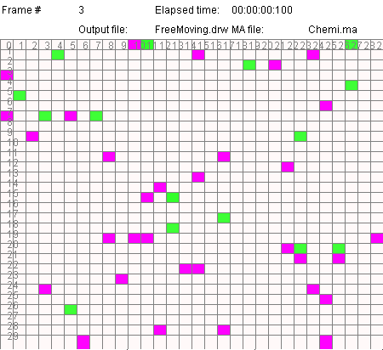
Figure 5: Frame 3-Free moving
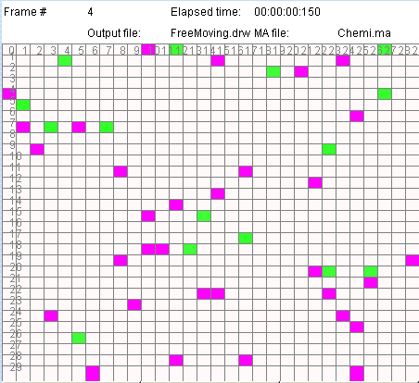
Figure 6: Frame 4-Free moving
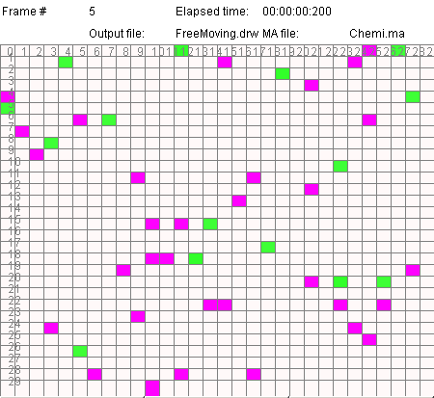
Figure 7: Frame 5-Free moving

As seen in the figures 3 to 7, the cells move randomly in their environment.

Testing the Transition rules:

Transition rules, as mentioned before, show the probability that a cell can transform to another type as time elapses. To test this rule all the other rules need to be deactivated and their values be set to 0. As an example we can set the probability of transforming from type 1 to type 2 to the value. This value is called TPxy in the macro file. The following figures show that if we set this value to 1 all the green cells becomes purple within one frame.

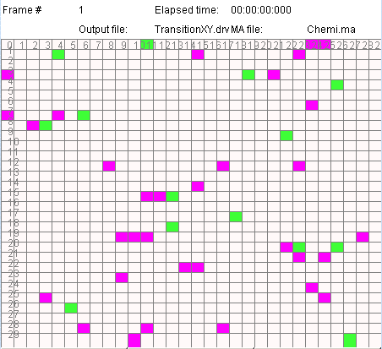
Figure 8: Frame 1-Transition from Type 1 to type 2 with the probability of 1
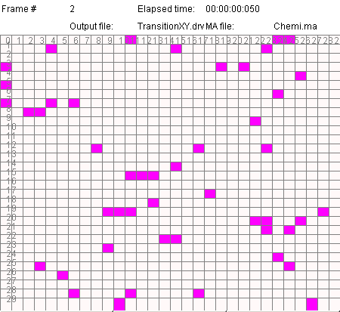
Figure 9: Frame 2-Transition from type 1 to 2 with the probability of 1

Setting the transition probability to 0.5 will change the second frame as shown below. As depicted in the snapshots of frame two, not all the green cells turn to purple due to lower probability.

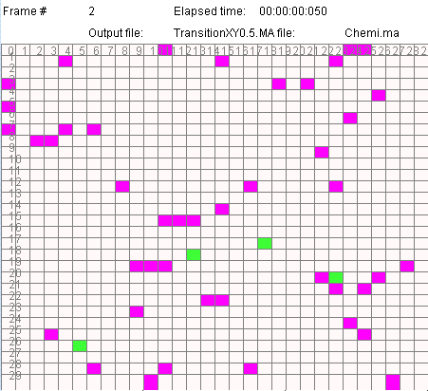
Figure 10: Frame 1-Transition from type 1 to 2 with the probability of 0.5

Testing the breaking rules:

To test the breaking rules we need to set all the probabilities to 0 and the breaking probabilities to a non-zero value. As an example we can set the breaking probability of ingredient type 1 to type 2 (BPxy) to 1. The results are shown in figure 11 to figure 12.

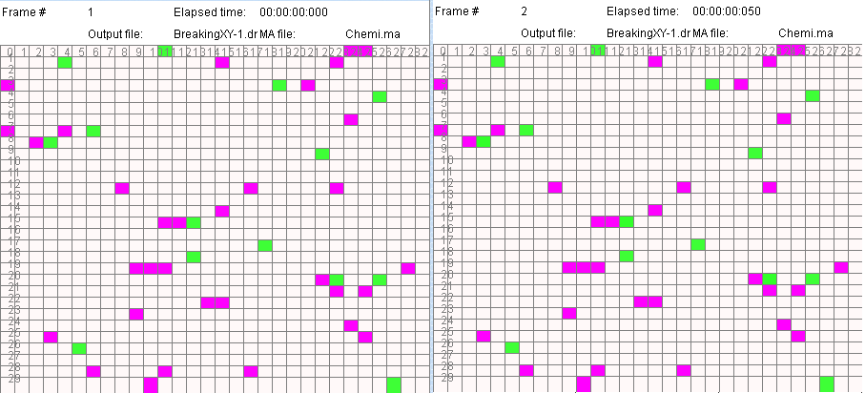
Figure 11: Frame 1&2-Breaking between type 1 and type 2 with the probability of 1
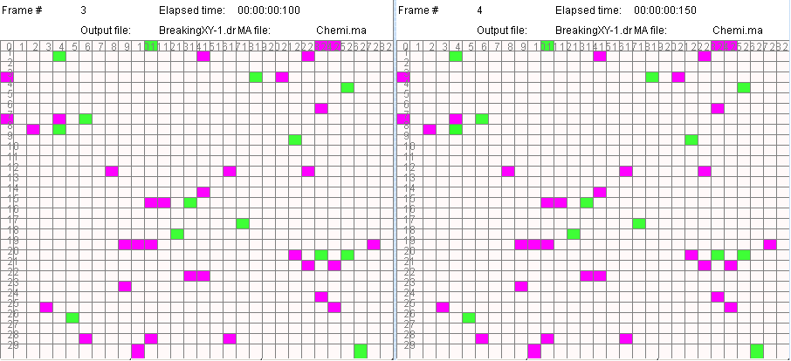
Figure 12: Frame 3&4-Breaking between type 1 and type 2 with the probability of 1

Testing the joining rules:

To test the breaking rules we need to set all the probabilities to 0 except for joining probabilities. As an example we can set the joining probability of ingredient type 1 to type 2 (JPxy) to 1. The results are shown in figure 13. It is clear that the type 1 cells try to stick to type 2 cells as soon as they find a vacant cell in between.

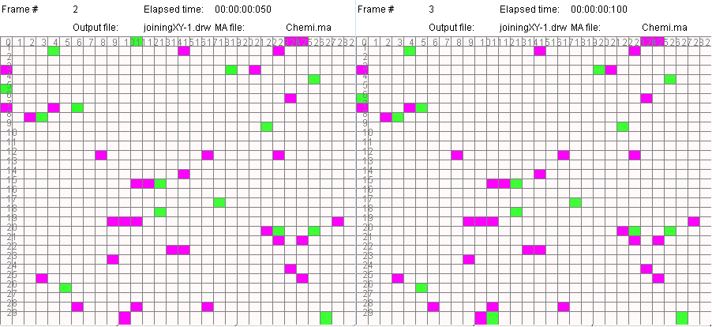
Figure 13: Frame 2&3-Joining between type 1 and type 2 with the probability of 1

DEVS Formalism

External Coupling Definition[2]

M = < X, Y, D, {Mi}, {Ii}, {Zij}, select>

M=<I,X,Y,Xlist,Ylist,η, N,{m,n}, C, B, Z, select>
Xlist=Φ
Ylist=Φ
η=9
I=<P^{X},P^{y}>,with P^{X}={Φ},P^{y}={Φ};
N={(-2,0,),(-1,0),(0,0),(1,0),(2,0),(0,1),(0,2),(0,-1),(0,-2)}
X=Y={0,1,2,3,4,5,6,7,8,9,10,11,12 };
m=10; n=10;
B={Φ};
C={Cij/iε[1,10], jε[1,10]}
Z:
P_{ij}^{Y1}→P_{i,j-1}^{X1} P_{ij+1}^{Y1}→Pij^{X1} P_{ij+2}^{Y1}→P_{ij+1}^{X1} P_{ij-1}^{Y1}→P_{ij-2}^{X1}
P_{i}j^{Y2}→P_{i+1j}^{X2} P_{i-1j}^{Y2}→P_{ij}^{X2} Pi-2j^{Y2}→Pi-1j^{X2} Pi+1j^{Y2}→Pi+2j^{X2}
Pij^{Y3}→Pij+1^{X3} Pij-1^{Y3}→Pij^{X3} Pij-2^{Y2}→Pij-1^{X3} Pij+1^{Y2}→Pij+2Y2
Pij^{Y4}→P_{i-1j}^{X4} Pi+^{1jY4}→^{PijX4} Pi+2j^{Y4}→Pi+1j^{Y4} Pi-1j^{Y4}→Pi-2j^{Y4}
P_{i}j^{Y5}→Pij^{X5} P_{ij}^{Y5}→P_{ij}^{X5}
Select={(-2,0,),(-1,0),(0,0),(1,0),(2,0),(0,1),(0,2),(0,-1),(0,-2)}

References

[1] L. B. Kier, P. G. Seybold and C.-K. Cheng, “Cellular Automata Modeling of Chemical Systems”. Springer, Amsterdam (2005)

[2] Gabriel A. Wainer, "Introduction to the DEVS Modeling and Simulation Formalism," in Discrete-event modeling and simulation: a practitioner's approach. Boca Raton, United States of America: CRC Press, 2009.

